**Part 1: INTRODUCTION**

1. **Project introduction**

* The objective of the system is to provide the facilities to all the people concerned with Vehicle Insurance. From the management point of view works can be done fast and more accurately as compared to existing manual system. From the customer’s point of view he can get immediate services without any kind of wasting of time whereas from the user’s point of view all kinds of transitions can be done in very easy and efficient manner.
* This project aims to develop a complete fully functional independent system with the intension of improving the productivity of the operations of company through speedy and accurate processing and efficient storage and retrieval of data. The basic aim behind this project to provide a complete solution that manages the records of vehicle insurance company.

1. **Main missions**

* The site should work well in all leading browsers including Chrome, IE, Firefox etc.
* Website helps customers buy vehicle insurance quickly and simply, reducing complexity and convenience. The brief

1. **Hardware Requirements**
   * A minimum computer system that will help you access all the tools in the courses is a Pentium 166 or better.
   * 128 Megabytes of RAM or better.
2. **Software Requirements**
   * Visual Studio .Net / ASP
   * IIS server
   * .Net Framework
   * Java Virtual Machine/ J2EE server
   * Notepad/Java editor
   * j2sdk1.4.1_02 (or later).
   * EJB Dev Kit
   * Java enabled web server
   * JSP / Servlets Dev. Kit
3. **Scope of work**

* DATA SECURITY.
* REDUCED PAPER WORK.
* REDUCED MANPOWER.
* INCREASED OPERATIONAL EFFICIENCY.
* INCREASED ACCURACY AND RELIABLITY.
* IMPORVE MORAL.
* REDUCE OPRATIONAL TIME.

**Part 2: ANALYSIS-DESIGN**

1. **Customer:**

* User needs to register as customer by providing the necessary information in the registration form and provide the user name and password
* Customer can login with unique user name and password.
* He can change the password.
* Can purchase the policy online: For purchasing the policy online, he has to fill in the application form which would capture all the required information about the vehicle. On successful payment, copy of policy would be generated which customer can save for the records.
* Initiate the claim by filling the claim form.

1. **Employee:**

* Employee will be admin who can login with admin user name and password.
* He can perform all the admin functions as maintaining the policy records, claim records, payment schedules etc.
* Following reports needs to be generated
  + Monthly sell of policies
  + Vehicle wise analysis
  + Claims report
  + Policies due renewals
  + Policies lapsed report

1. **Sitemap:**

Contact us

Sitemap

Information

Login / Register

Write testimonials

Insurance Registration

Testimonials

Account

Insurances

Home

**Part 3: USER MANUAL**

* 1. **Home page**
* The homepage has 4 main sections: logo and menu, company purpose, company priorities, some information of members in the company.
  1. 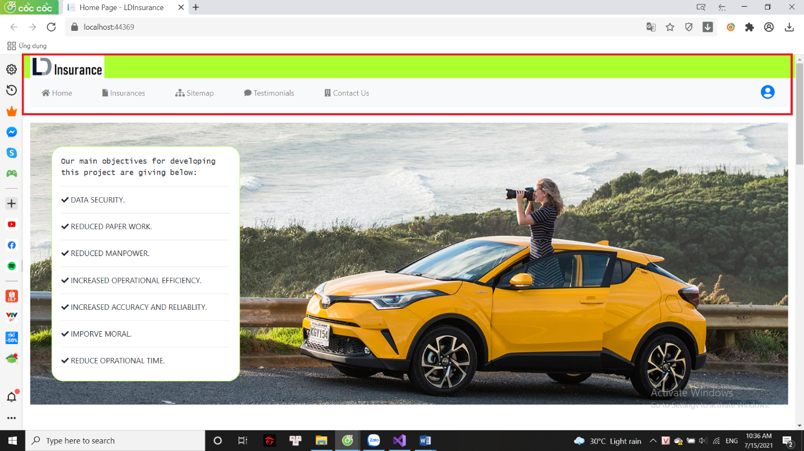**Logo & Menu**
* The logo when clicked will return to the homepage.
* The menu includes the main pages of the website: Home, Insurances, Sitemap, Testimonials, Contact us, Account.
  1. **Company purpose**

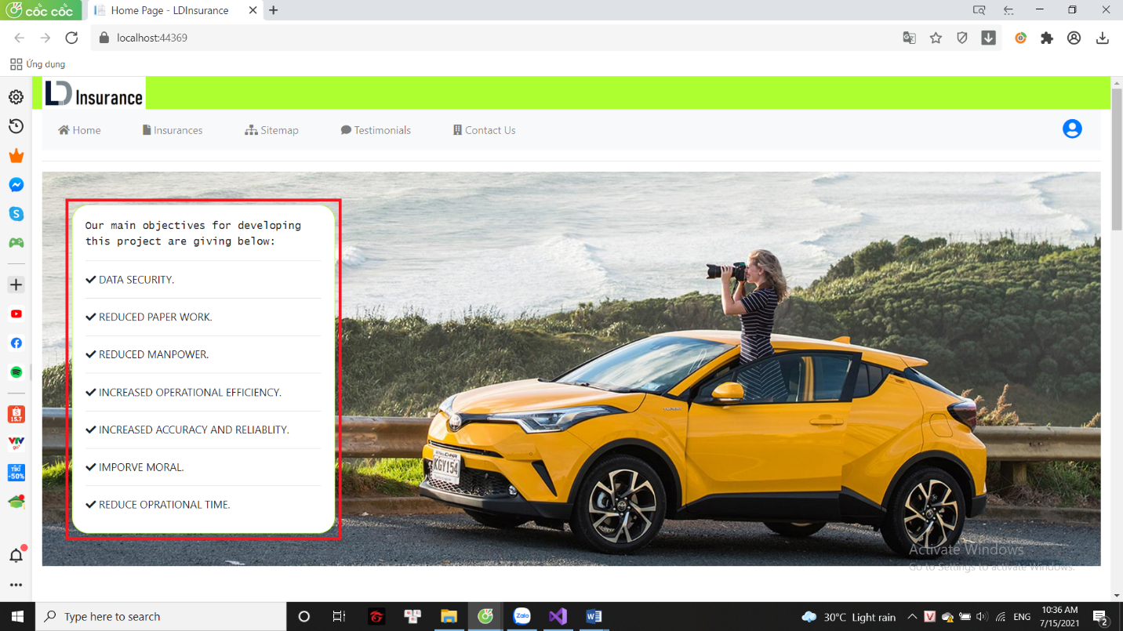

* The company's goals set out to serve customers:
  + DATA SECURITY
* REDUCED PAPER WORK
* REDUCED MANPOWER
* INCREASED OPERATIONAL EFFICIENCY
* INCREASED ACCURACY AND RELIABLITY
* IMPORVE MORAL
* REDUCE OPRATIONAL TIME
  1. 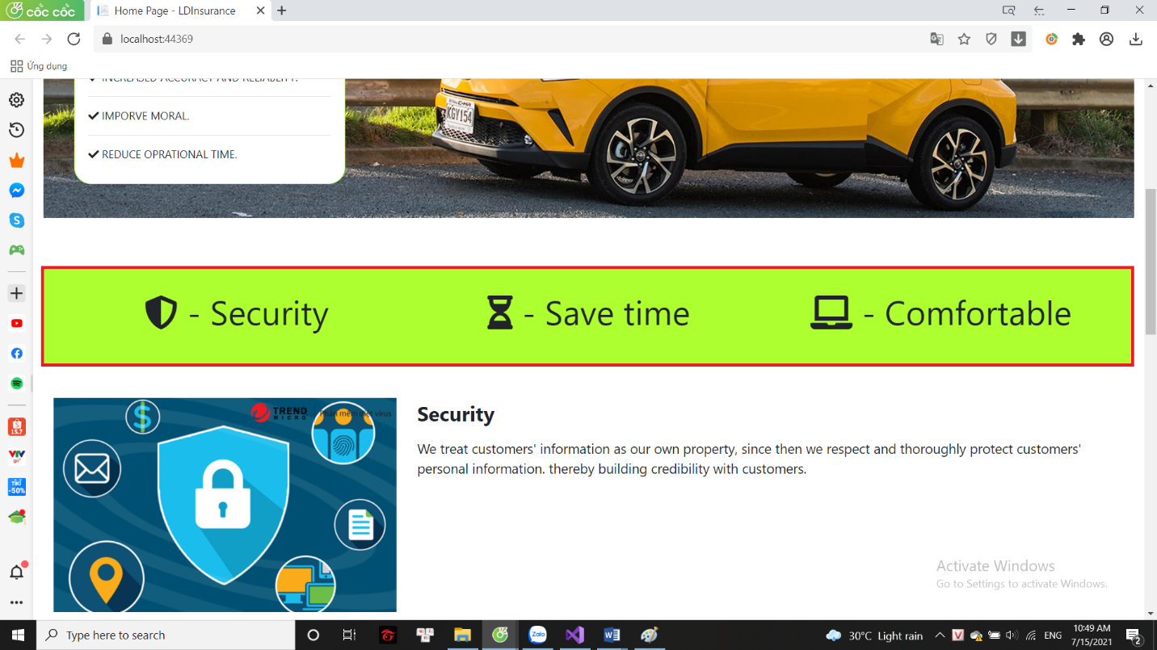**Company priorities**
* The company's top priorities set to create customer satisfaction:
  + **Securiy:** We treat customers' information as our own property, since then we respect and thoroughly protect customers' personal information. thereby building credibility with customers.
  + **Save time:** We sympathize with you about your time and work, from which we are committed to saving your time. so you don't need to worry about complicated paperwork.
  + **Comfortable:** You just need to add information at home. Let us take care of the rest, instead of having to go to the company to fill out information, now you can register at home, pay at home, receive insurance at home.
  1. 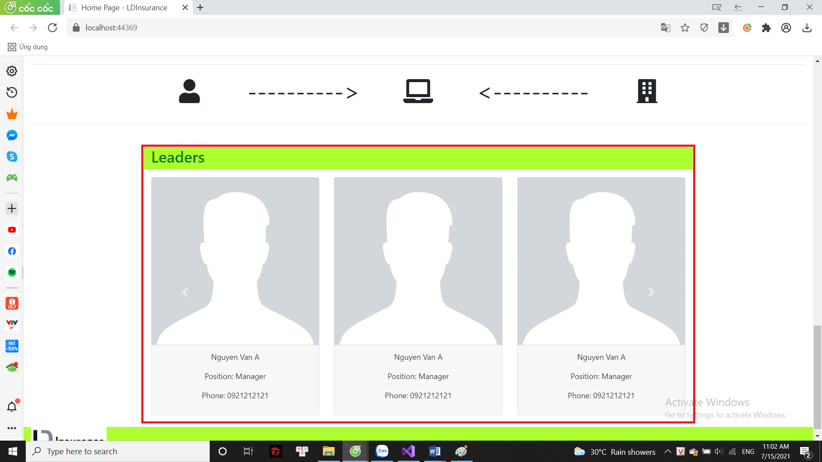**Some information of members in the company**
* Here is a summary of information of some high-ranking members of the company: name, phone number, position in the company.
  1. **Account**
* ****If the customer is not logged in, clicking the user icon on the menu bar will return to the login form.
* 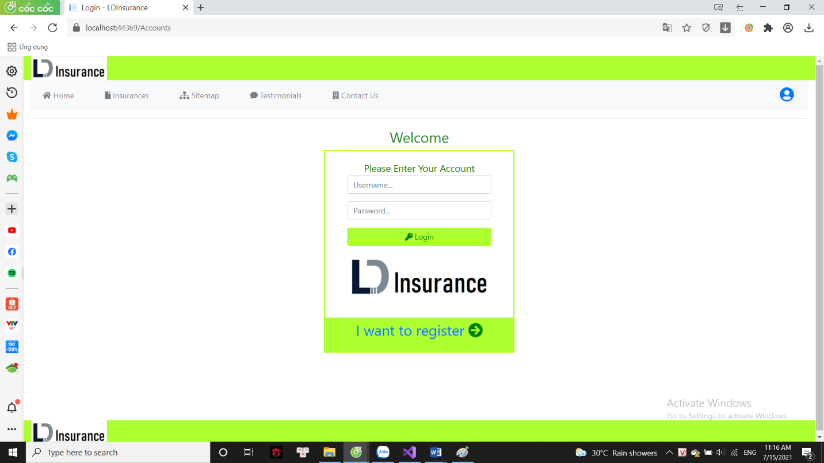Login form:
* 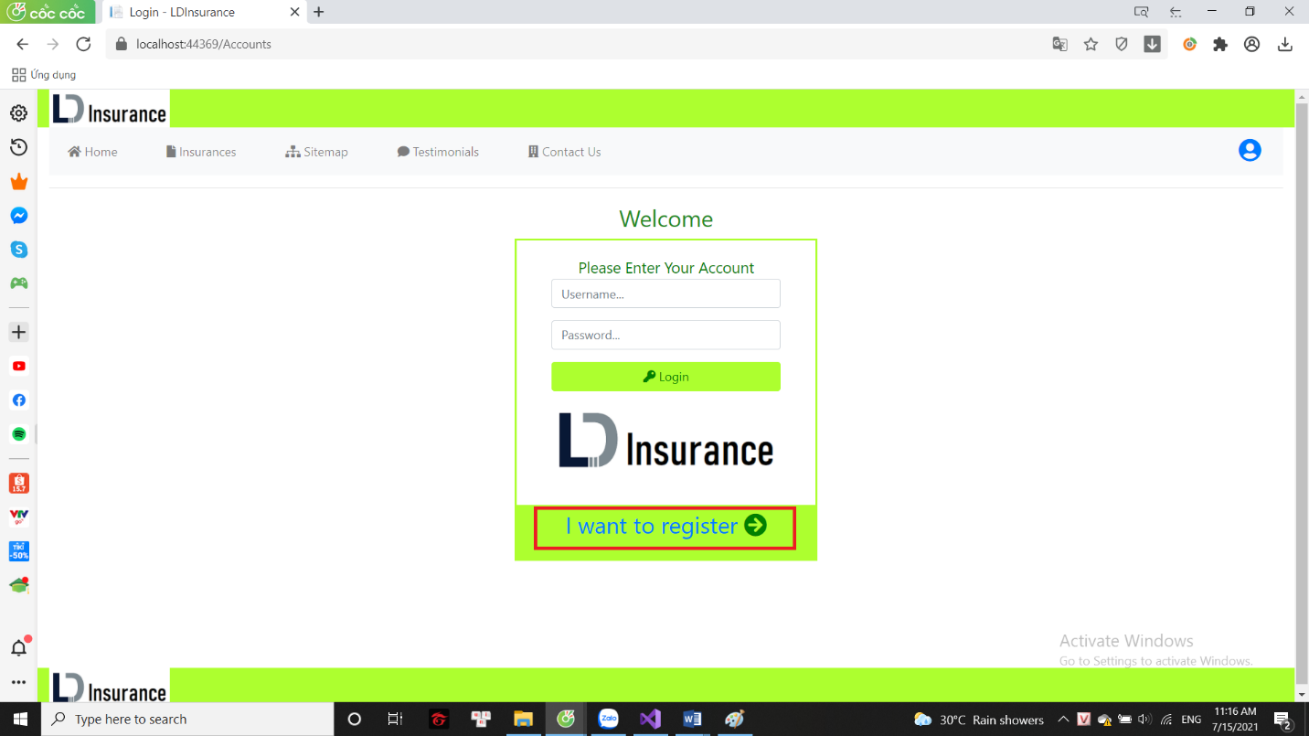Register:
* 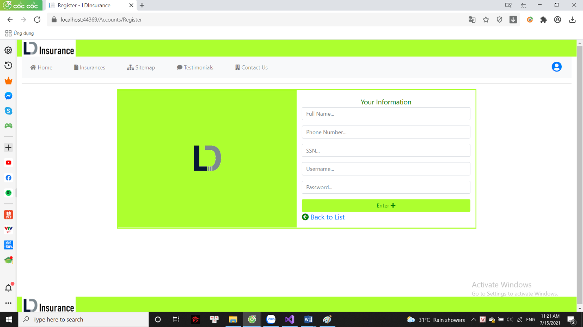Register form:
* User can register an account
* Unable to create an account with an already used account name

* After the user logs in, they will return to the customer's personal information page. Now when you click on the user icon on the menu bar, you will return to this page.

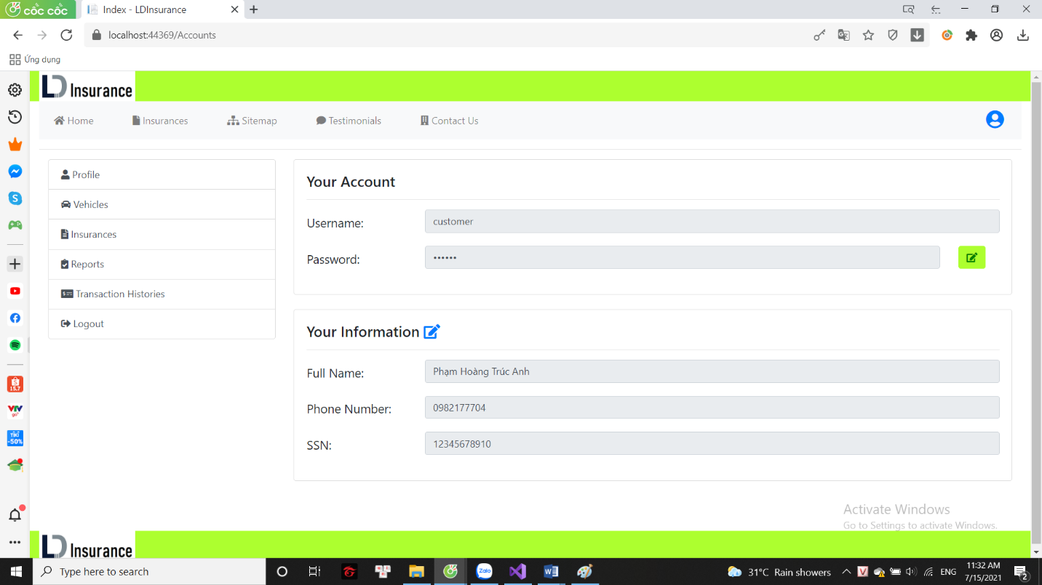

* On this page, customers can view their personal information and can also change their personal information (except username).
* The left side shows the menu page with the customer's personal data.
* 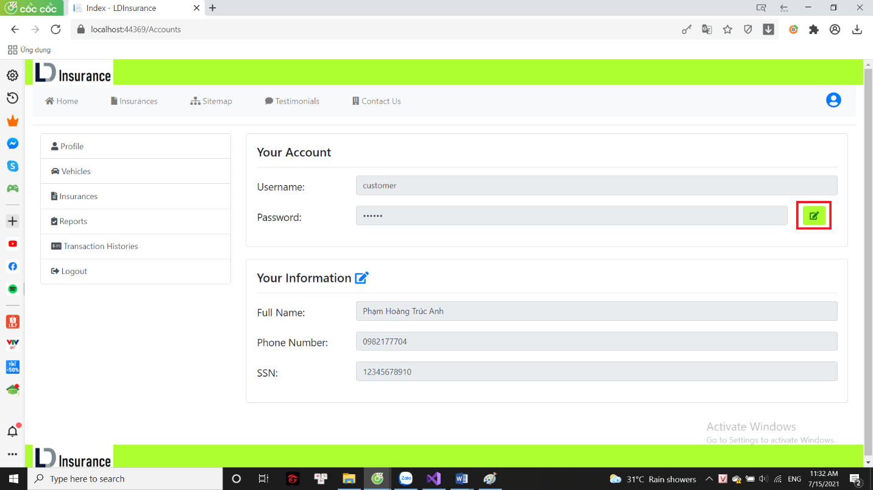Change password

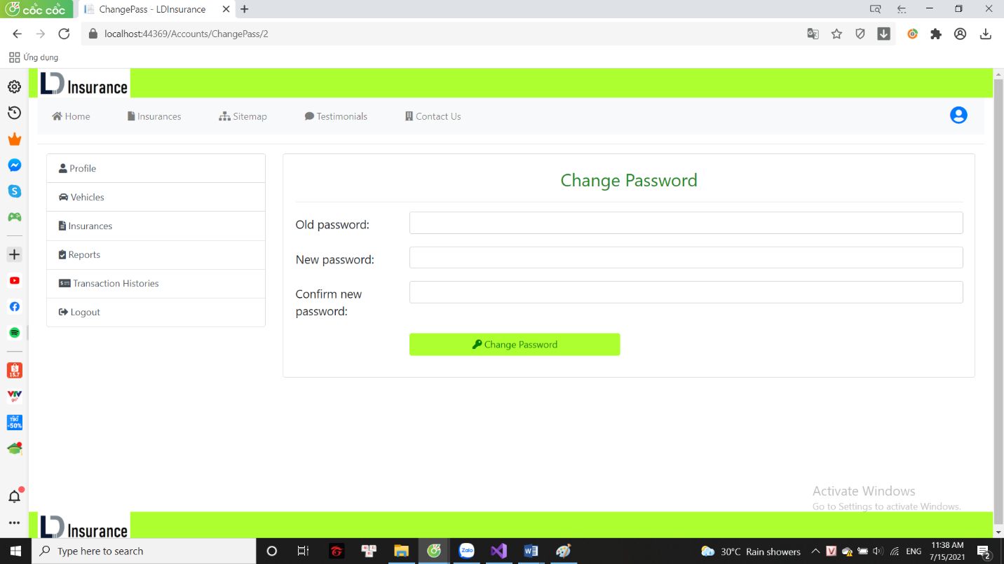

* 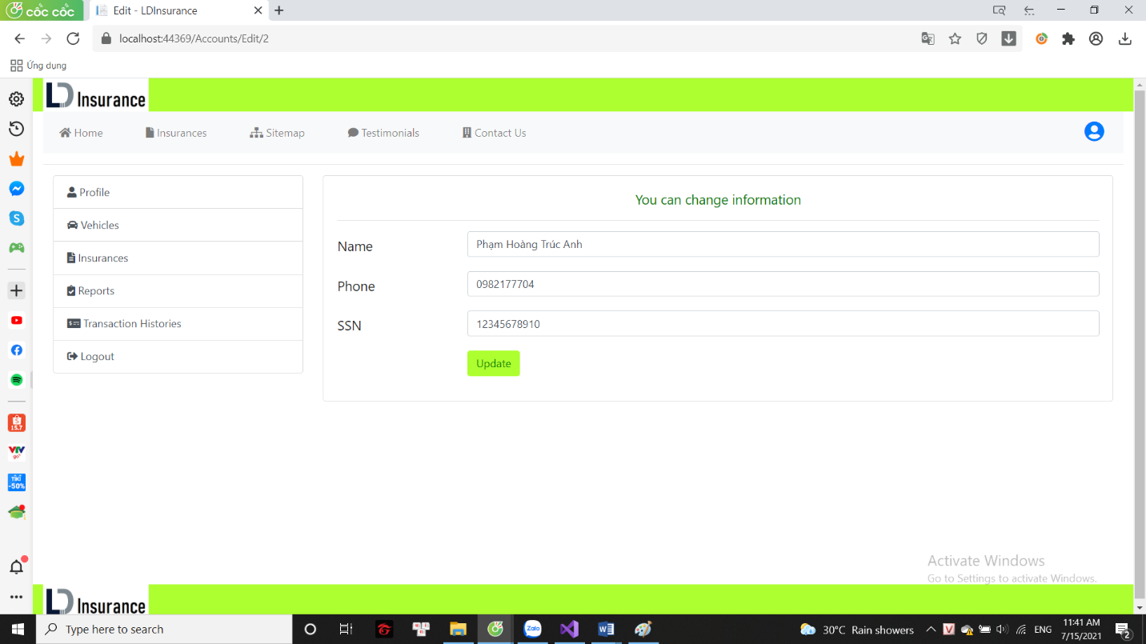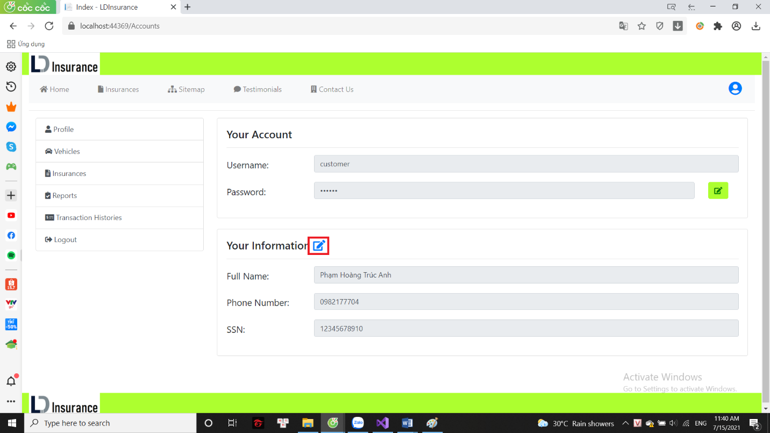Edit information
* 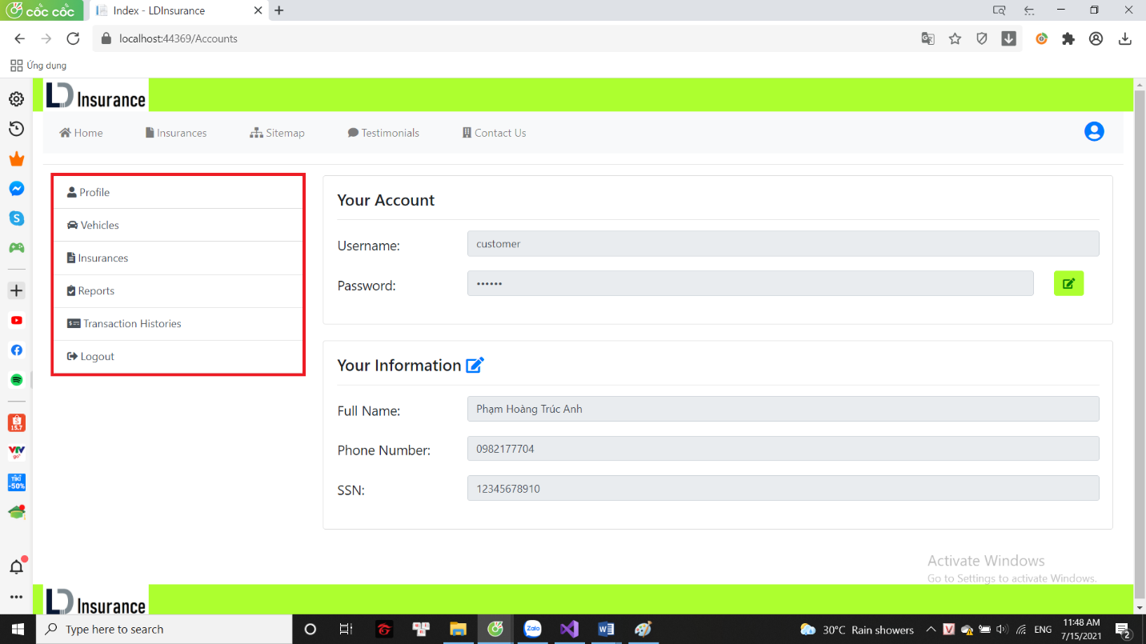User menu
  + Profile: user’s information
  + Vehicles: list of registered vehicles (including uninsured vehicles)
  + Insurances: registered insurance list (including unpaid)
  + Reports: list of submitted customer reports
  + Transaction Histories: bills the customer has paid
  + Logout: user logs out of the account
  1. **Insurances**
* 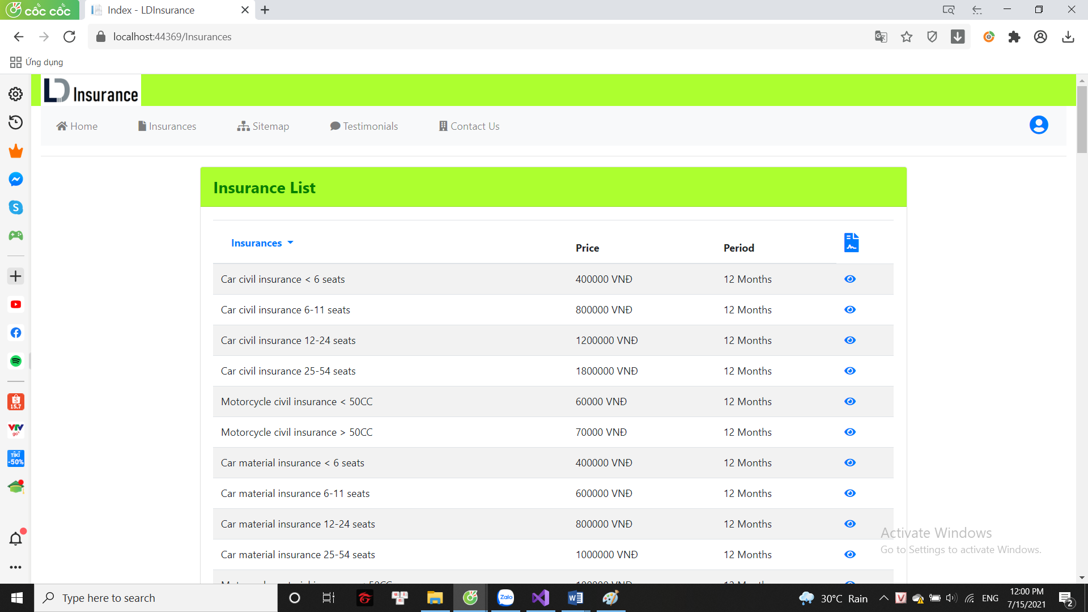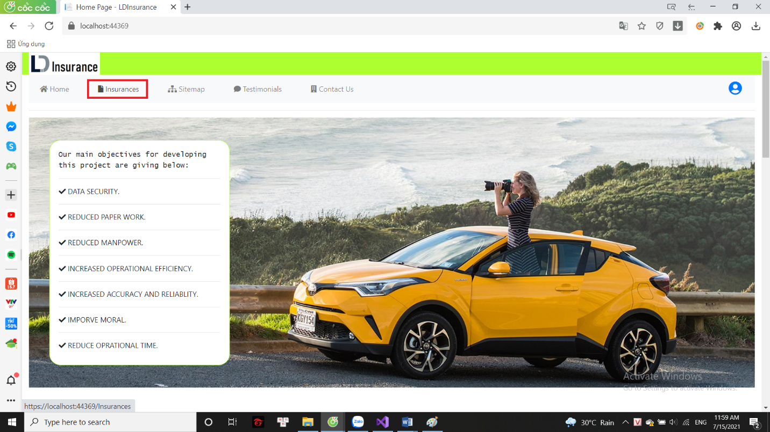This is a page that includes all the types of insurance the company sells, prices, periods and even the basics of insurance.
* 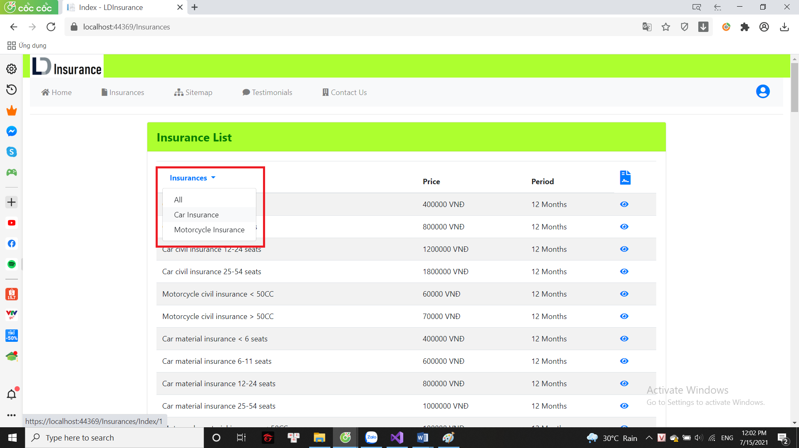Can filter out the types of insurance under your vehicle type
* 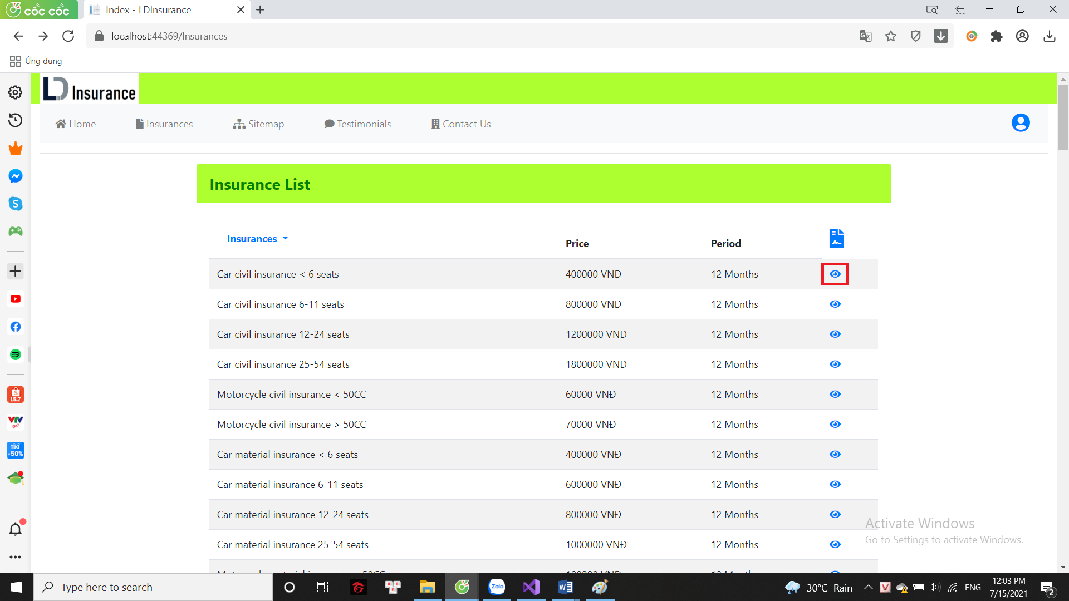View insurance information
* 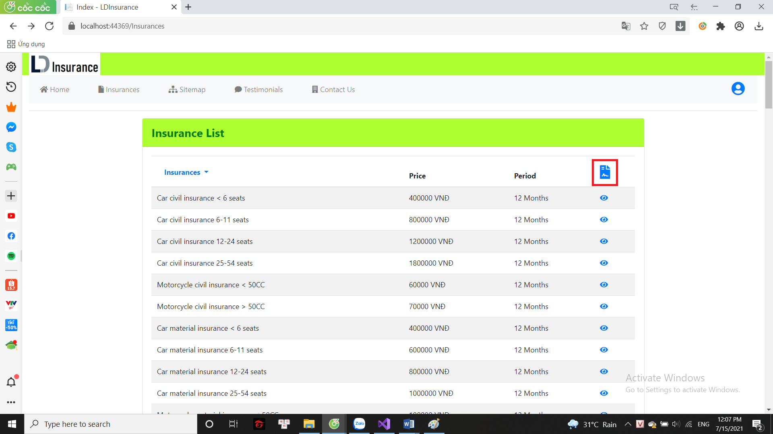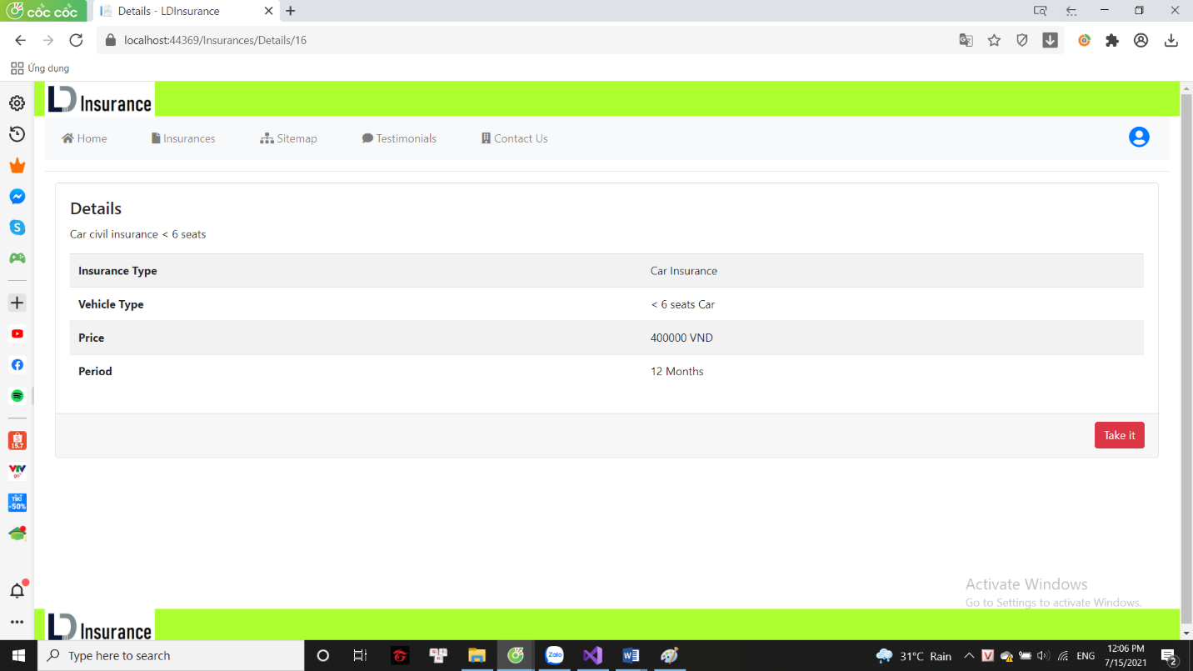 Register to buy insurance for vehicles

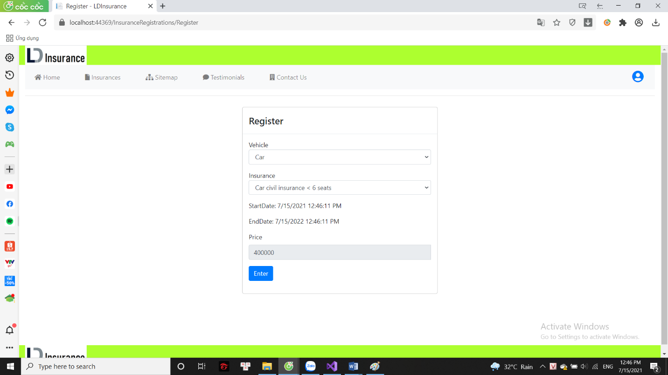

* + Vehicle: customer's vehicle
  + Insurance: list of registered vehicles (including uninsured vehicles)
  1. **Sitemap**
* This page includes all the links of the website

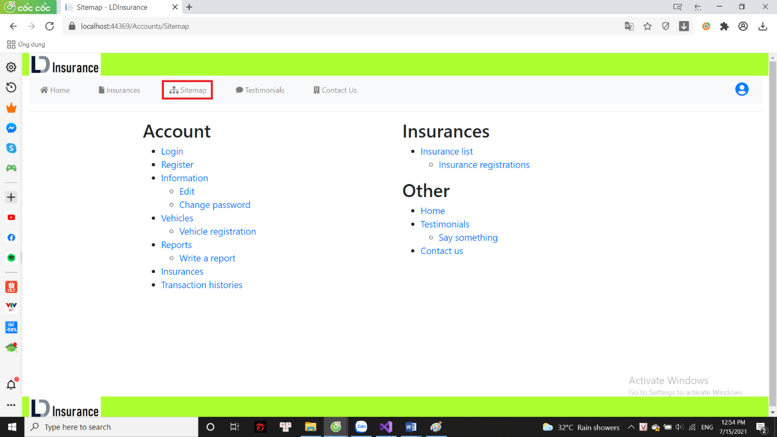

1. 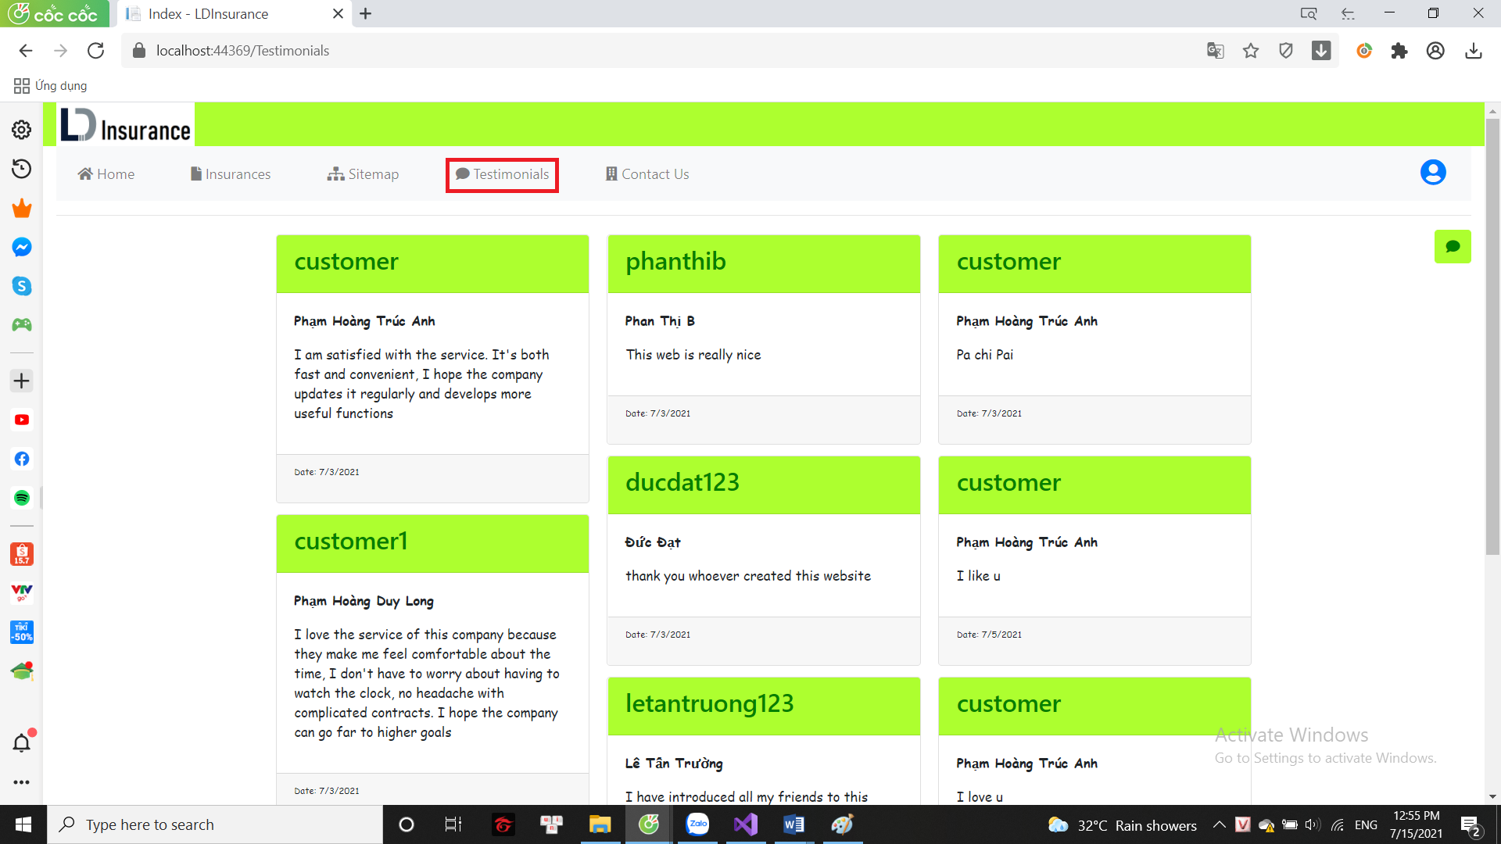**Testimonials**

* This page includes customer service reviews.
* 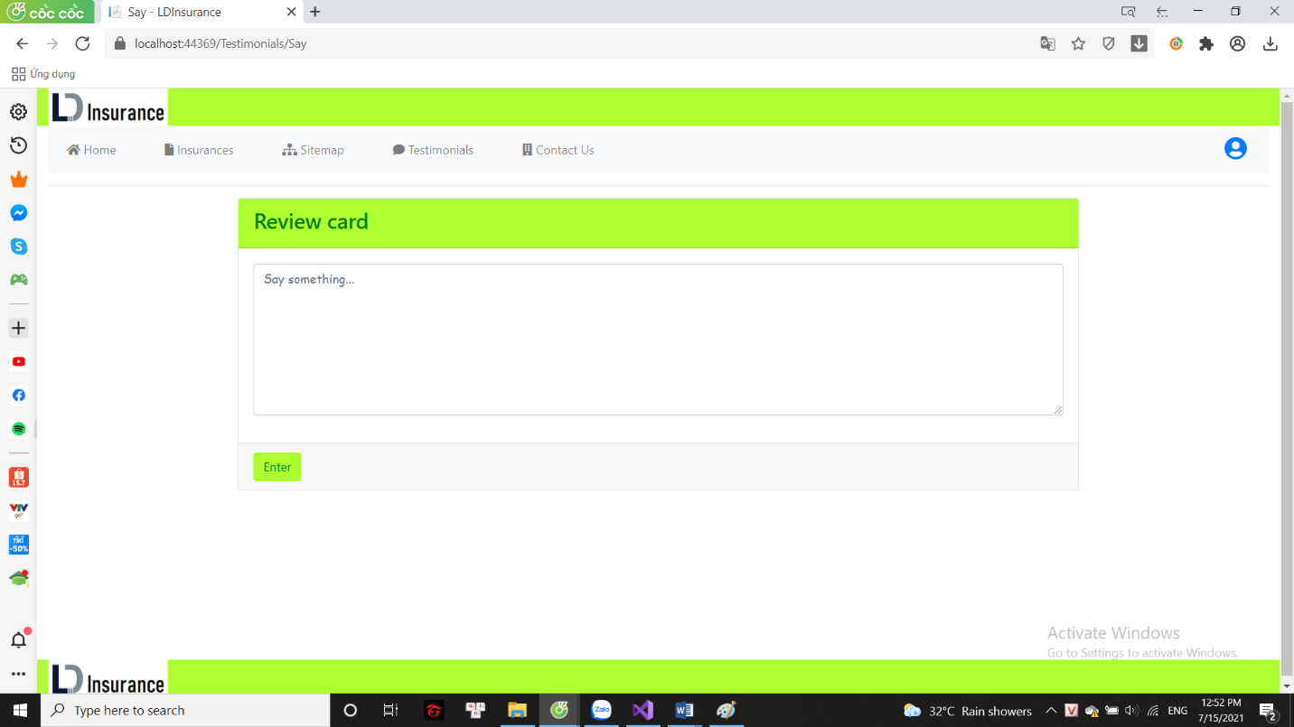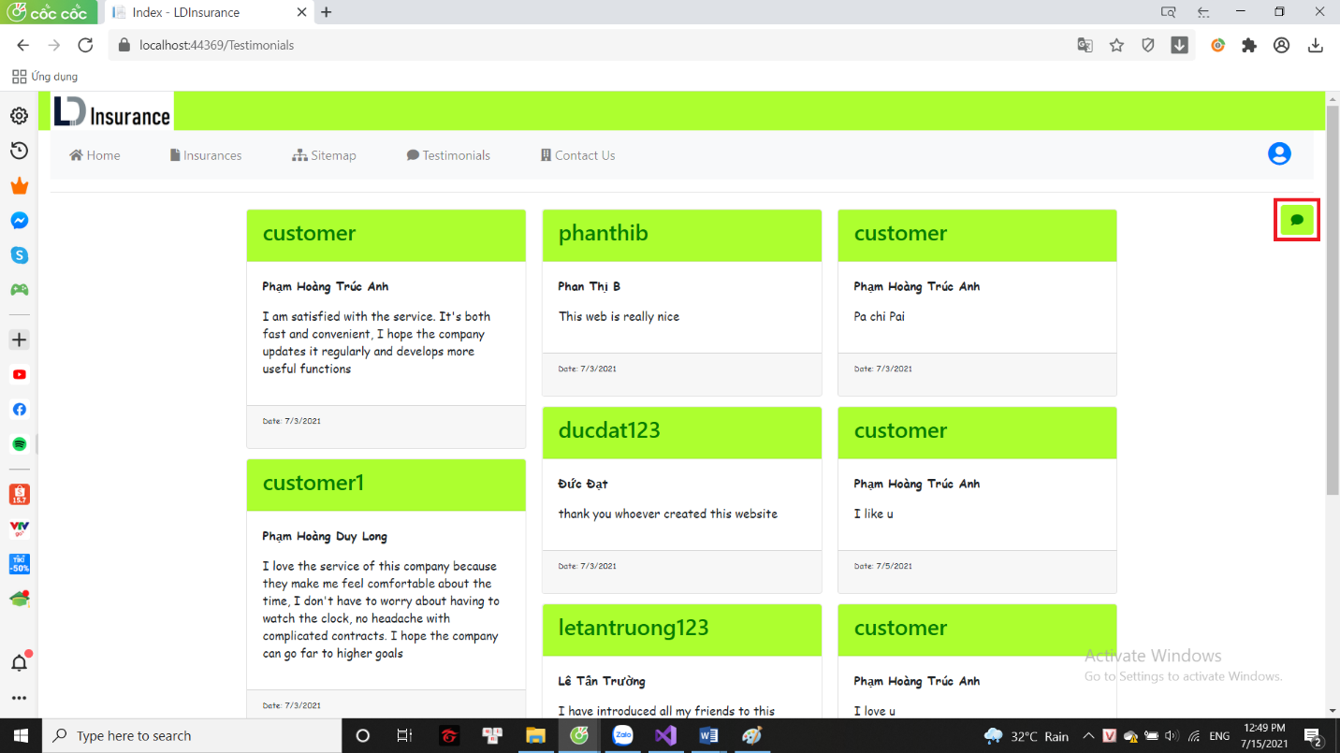Click on the icon in the right corner to give your own assessment.

1. **Contact us**

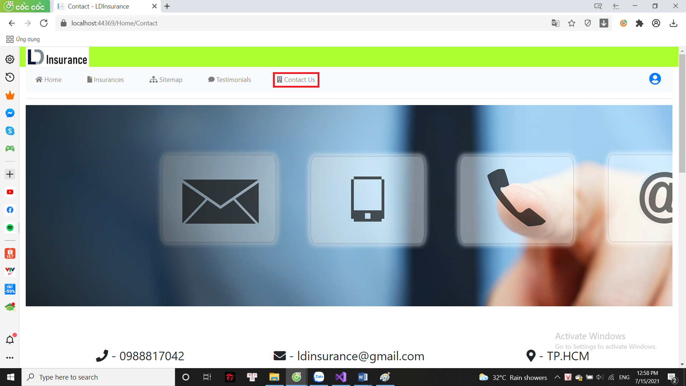

* + Contact information: phone number, email, company address.
  + Map: company address.
  + About us: Some words of staff to customers.

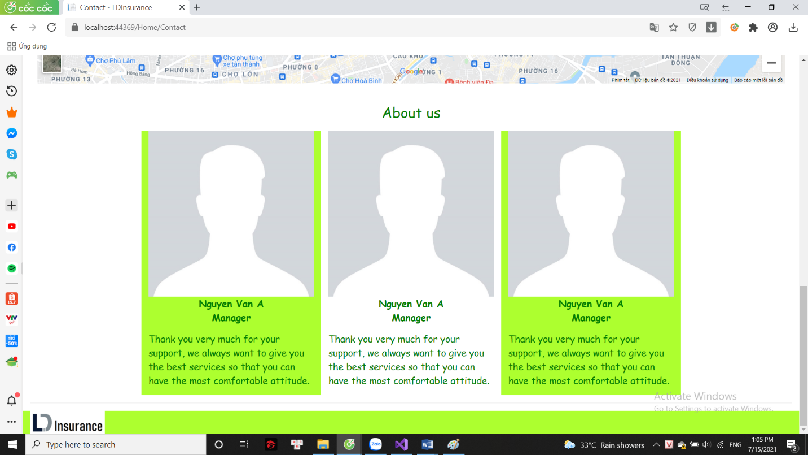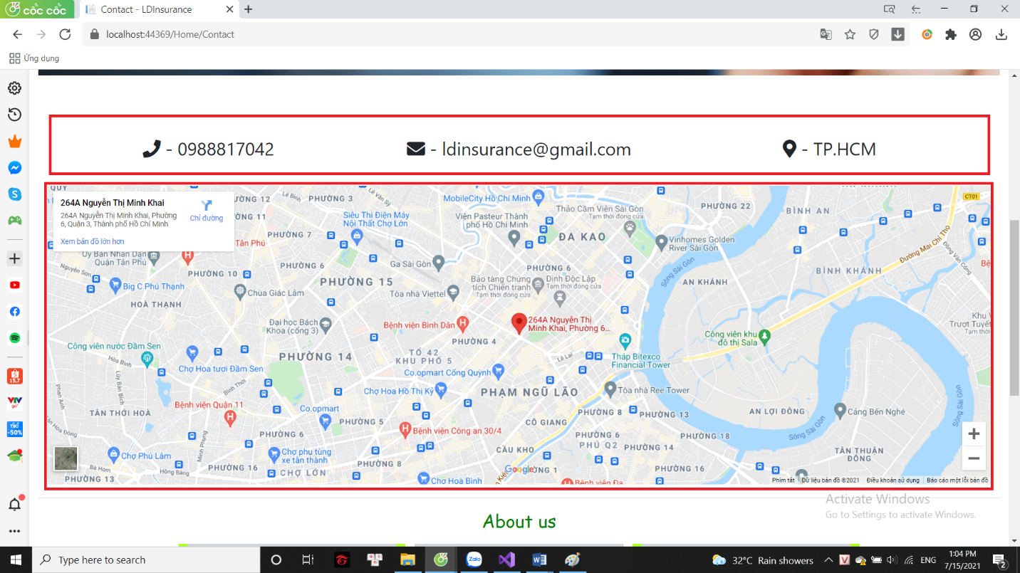

1. **Some extra features for customers**
   1. 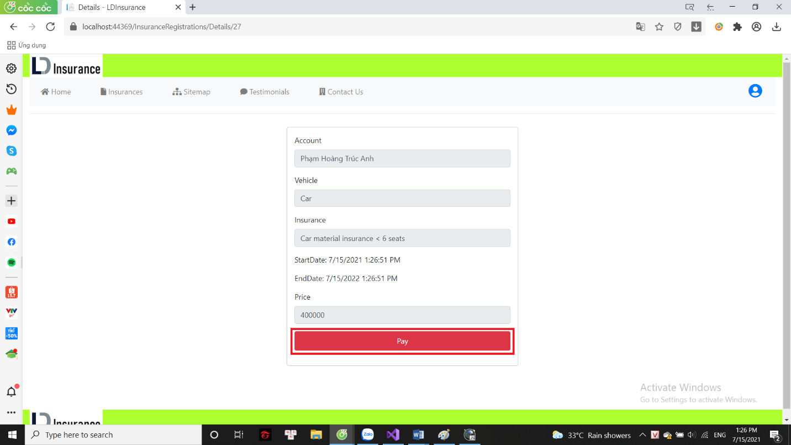**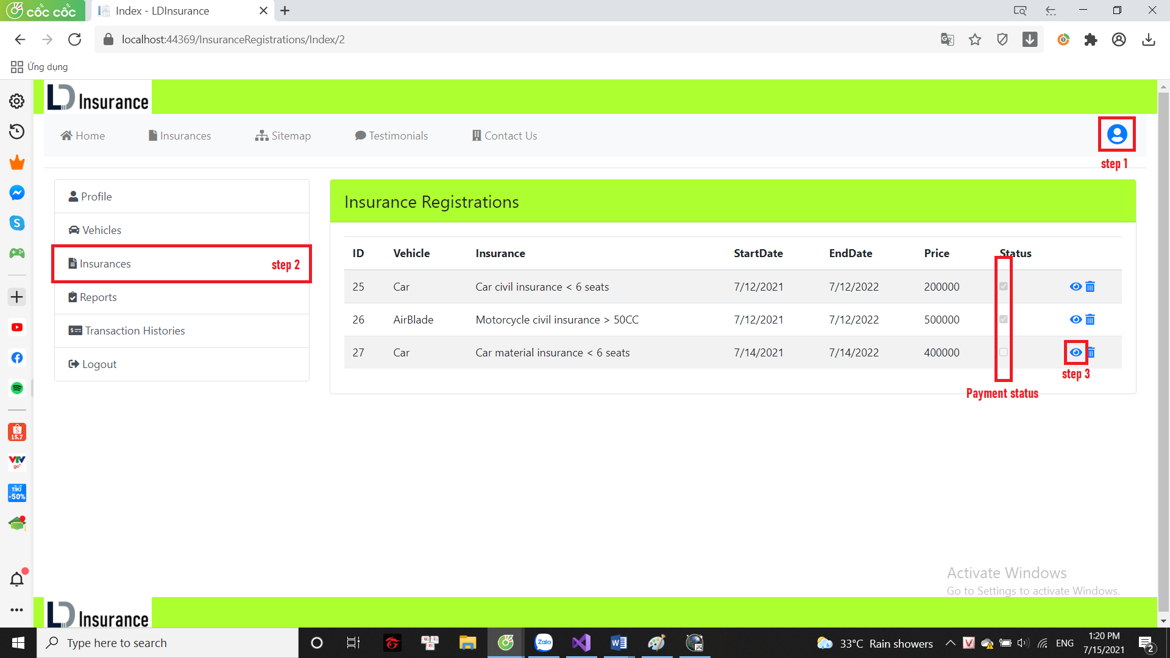Payment feature**

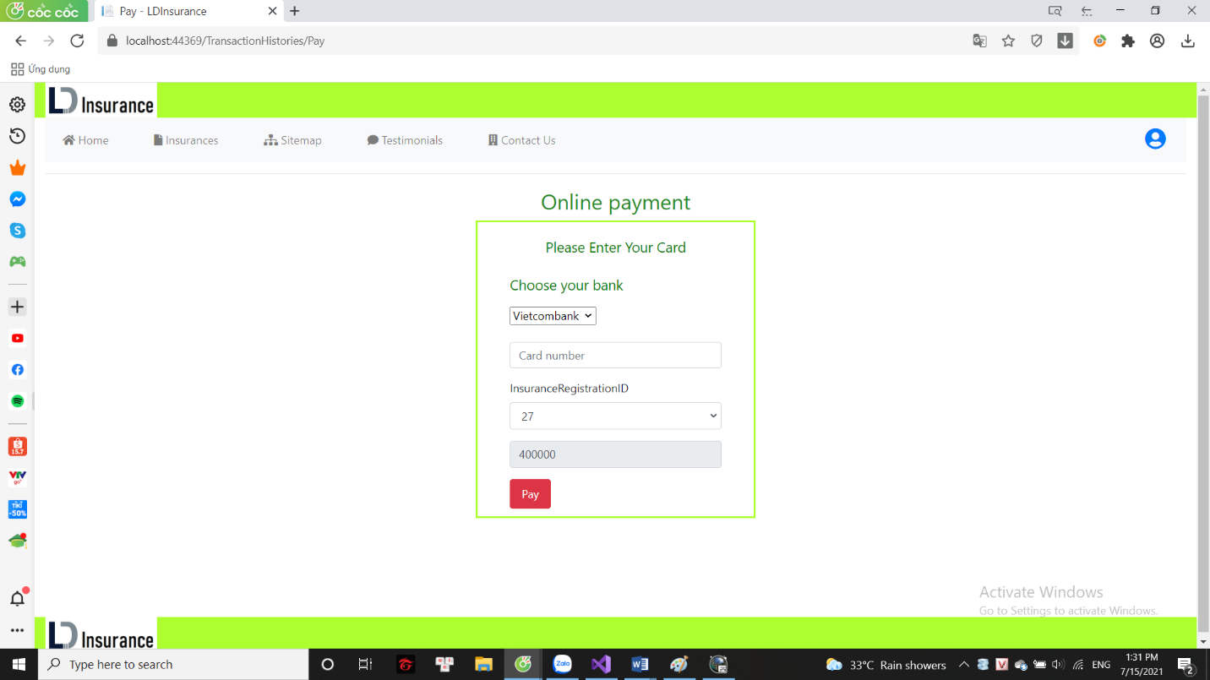

* + Choose your bank
  + Card number
  + Registered insurance
  1. **Write and send report**
* Write and send reports when you need the company to subsidize insurance costs

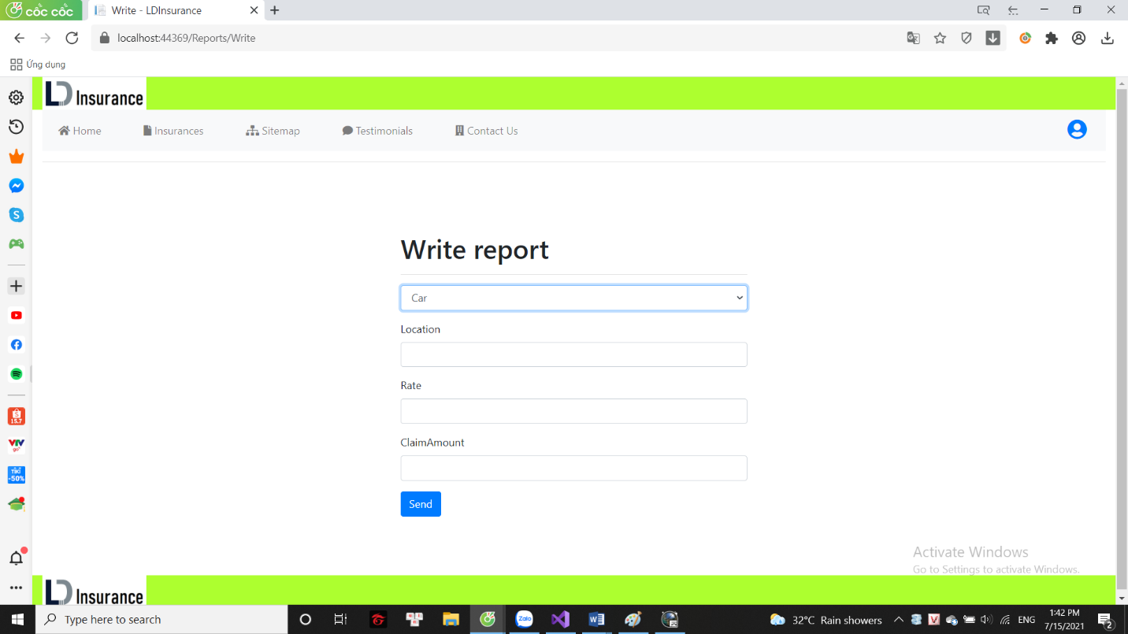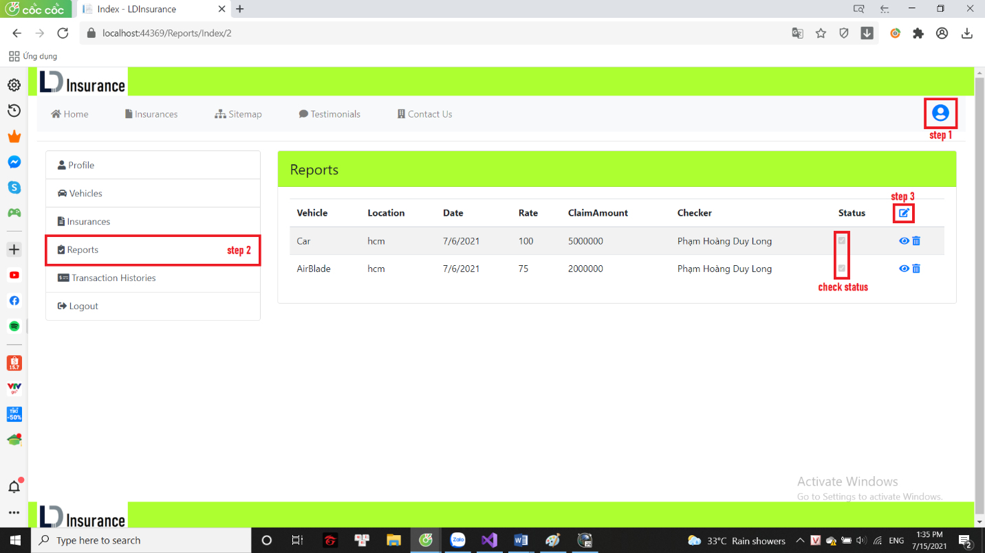

**Part 4: ADMIN**

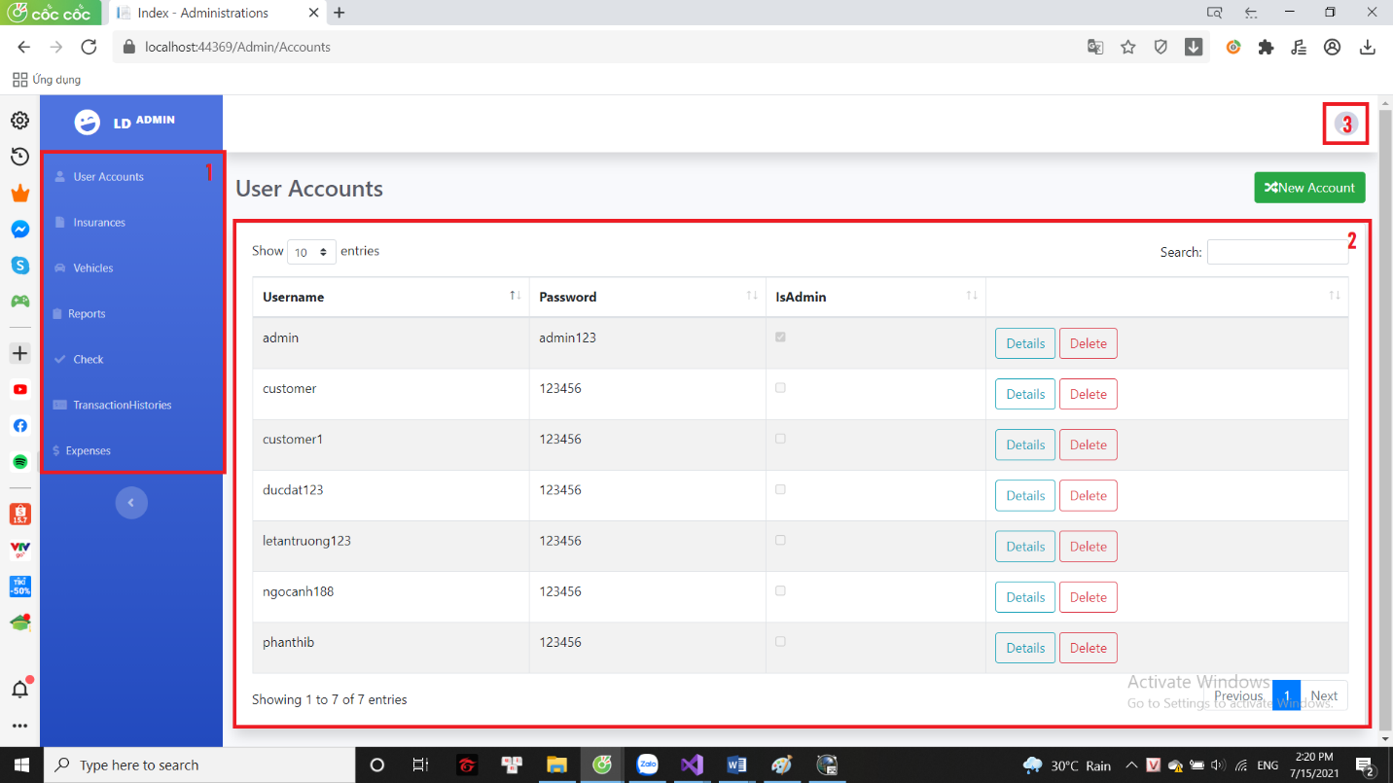

* + 1: admin menu
  + 2: data sheet
  + 3: logout

**1: Admin menu**

* + User accounts: list of all accounts
  + Insurances: list of all registered insurances
  + Vehicles: customer vehicle list
  + Reports: list of unapproved reports
  + Check: List of expired insurances
  + Transaction Histories: paid list
  + Expenses: list of expenses paid by the company

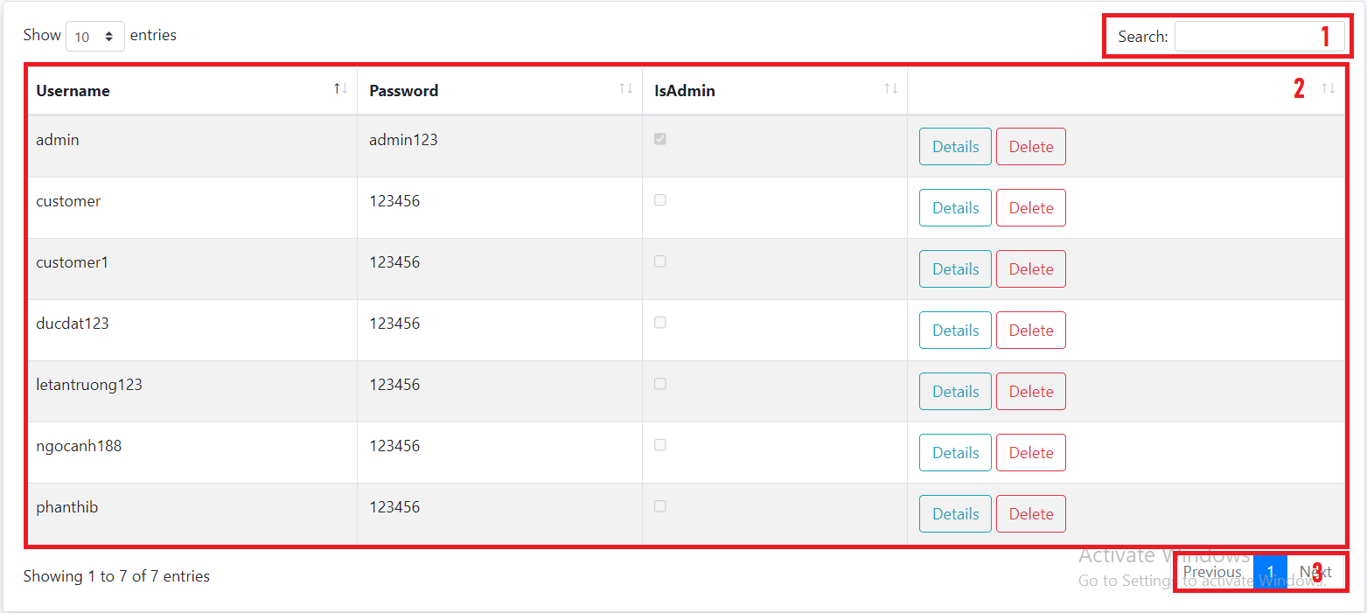**2: Data sheet**

* + 1: Search
  + 2: list of data to search
  + 3: number of pages

**3: Some other datasheet**

1. **Approved reports**

* This is the list of reports approved by the admin

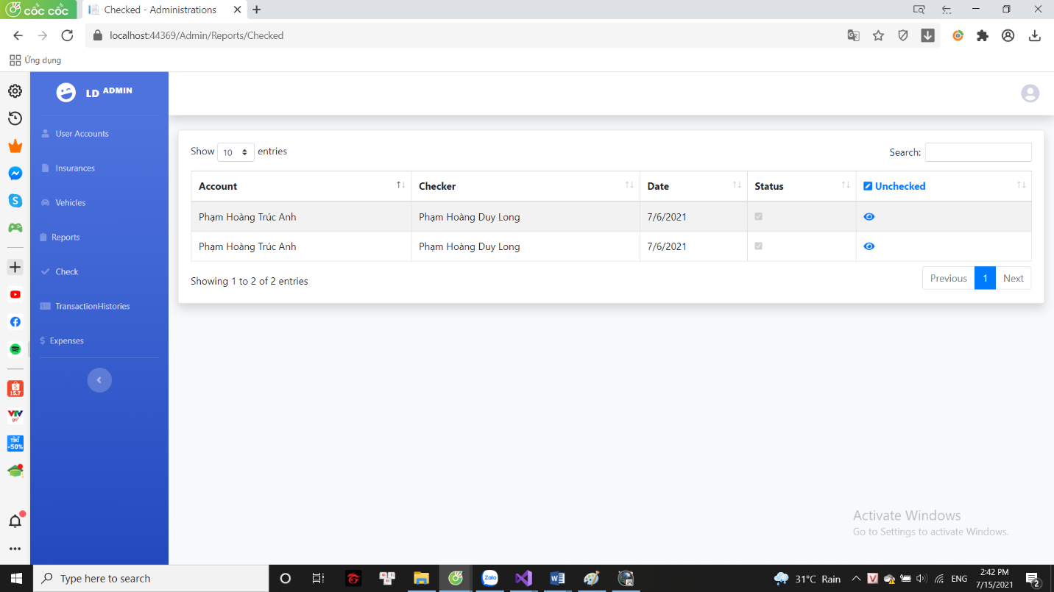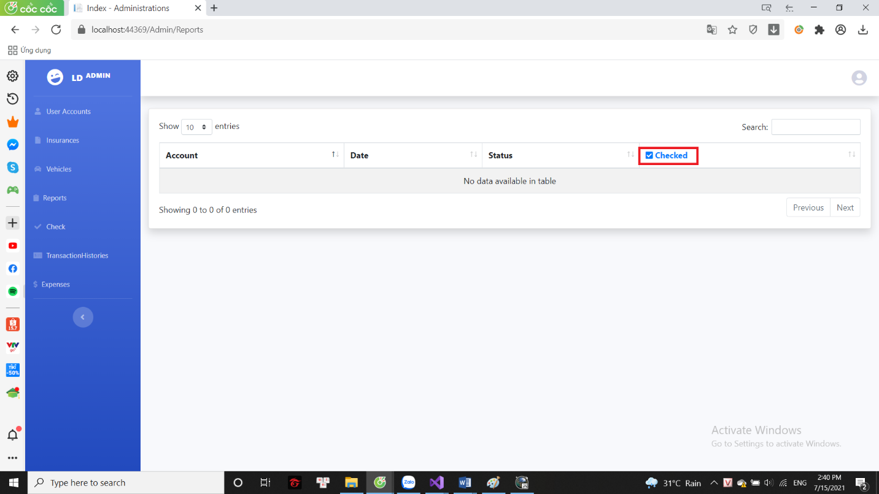

1. 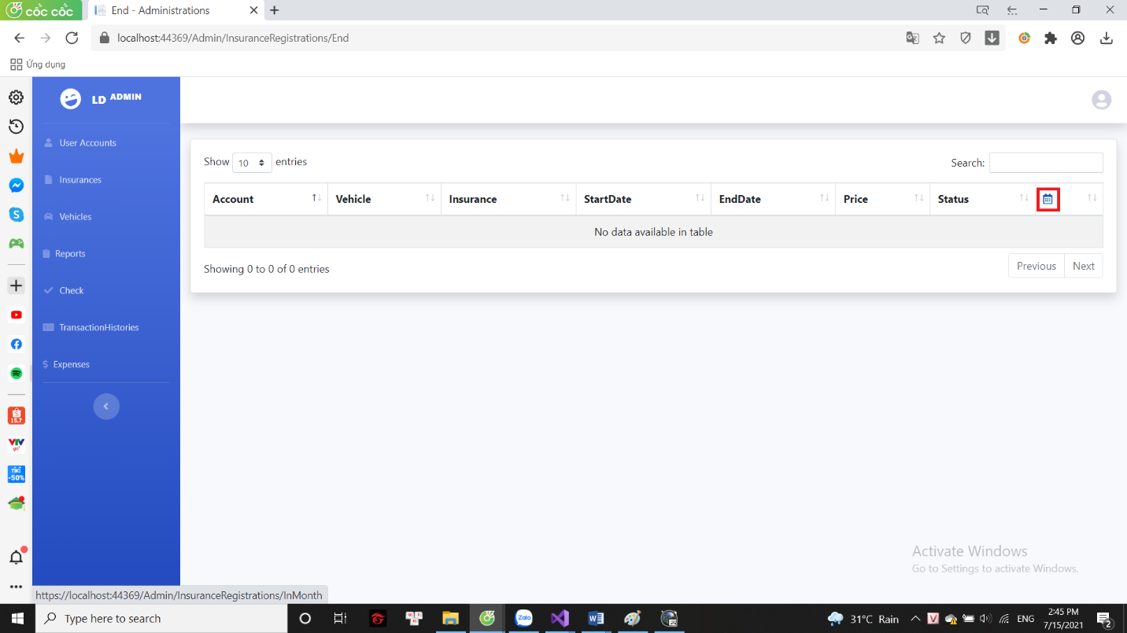**List of insurances sold during the month**

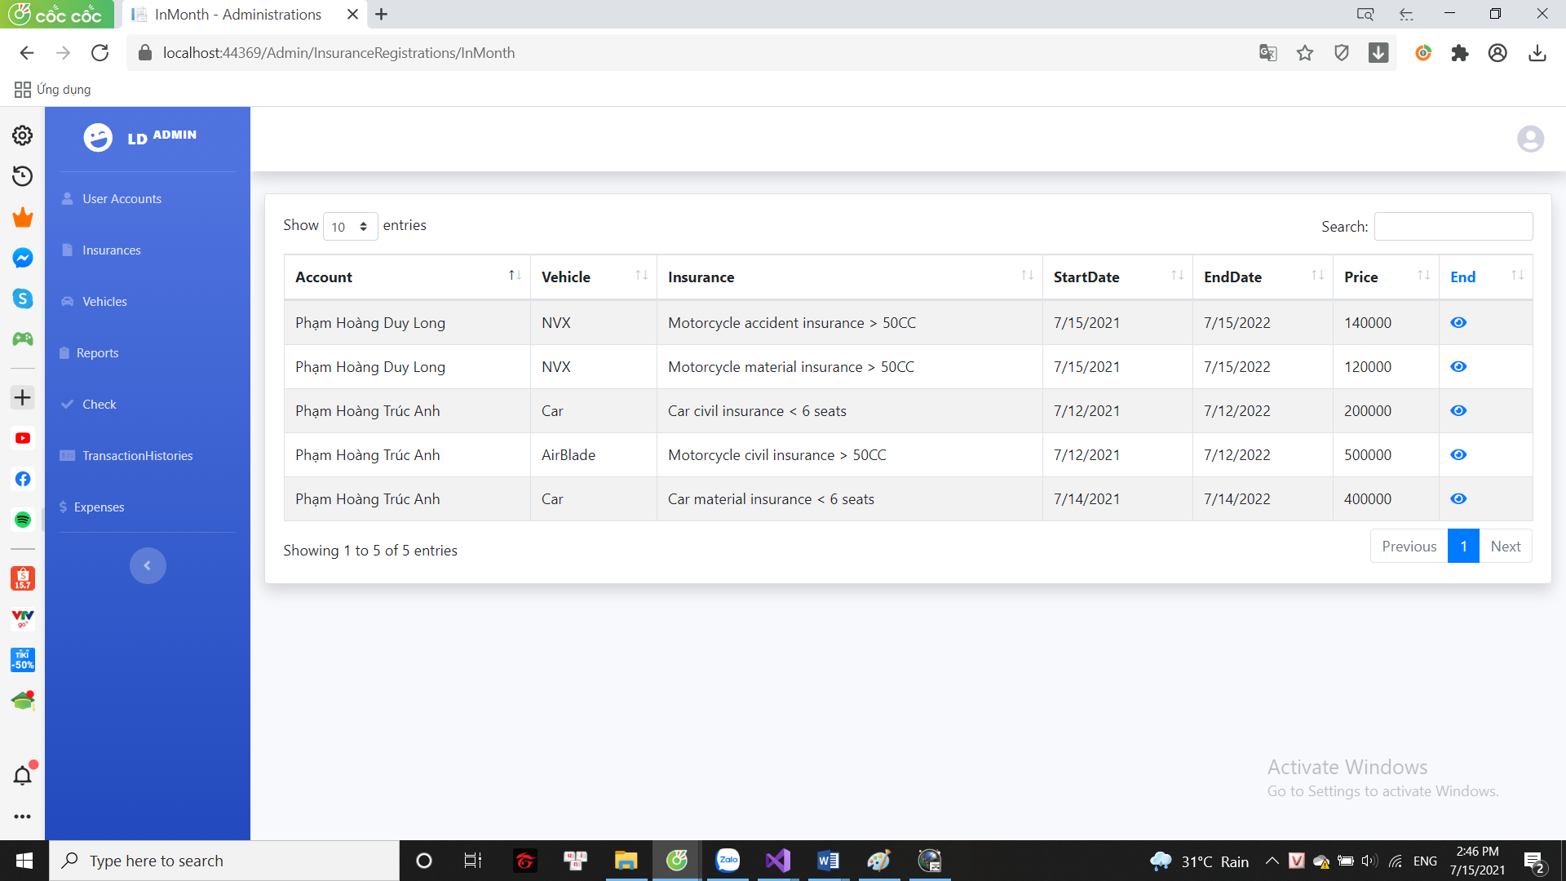

**4: Some actions of admin**

1. 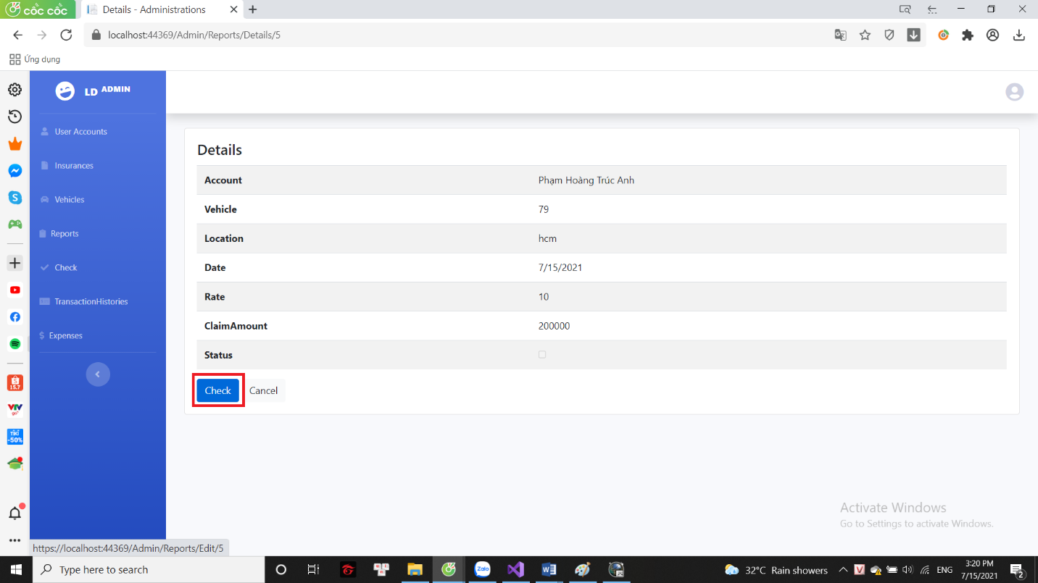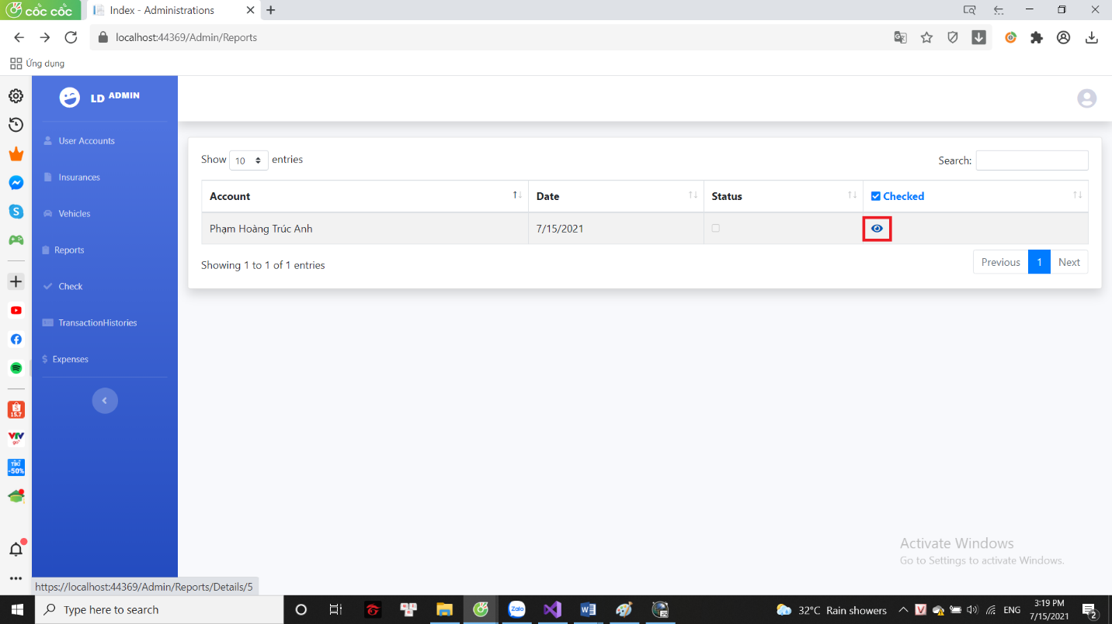**Check reports**

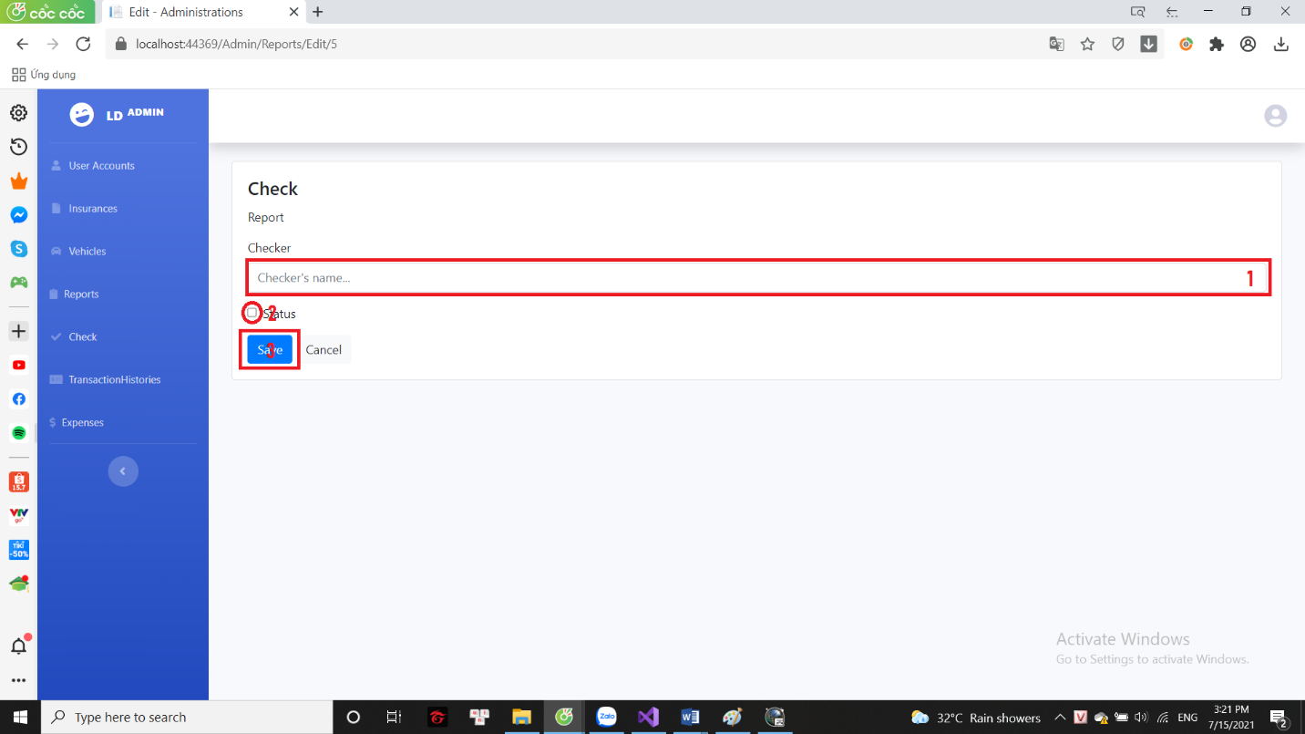

1. 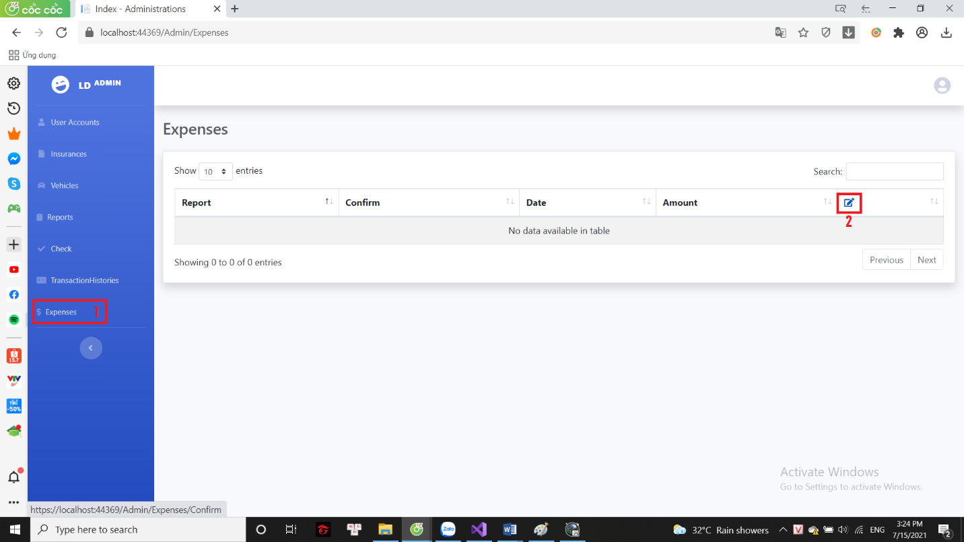**Write to support insurance money**

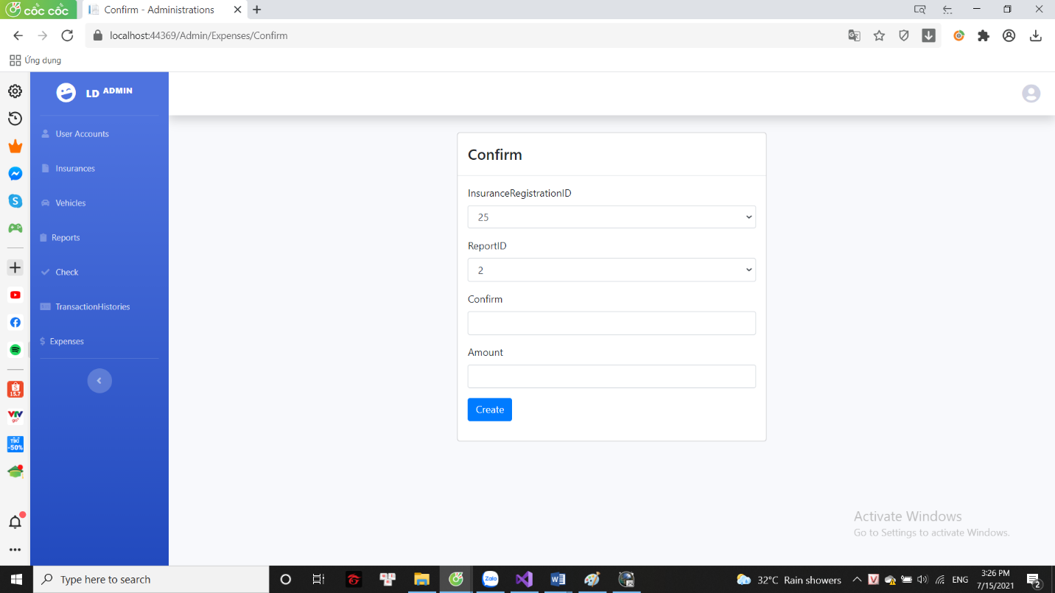

1. 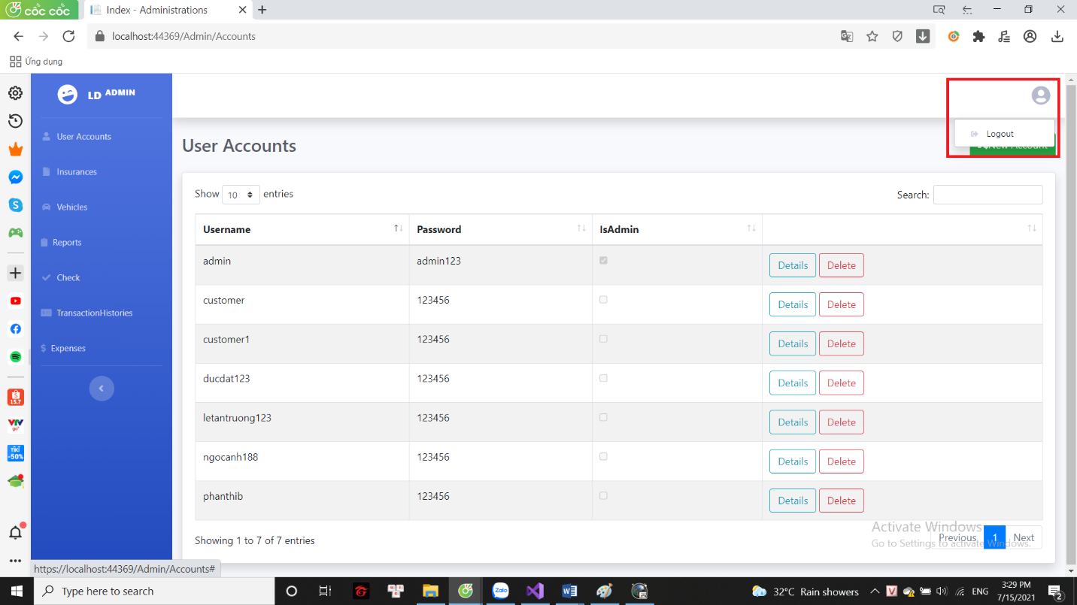**Logout**

**Part 5: Distribution Table**

|  |  |  |  |  |  |
| --- | --- | --- | --- | --- | --- |
| **Task** | **Descreiption** | **Start** | **End** | **Member** | **Status** |
| Use case | Use case diagram construction | 18/6/2021 | 18/6/2021 | Long | Done |
| Database | Build database | 19/6/2021 | 21/6/2021 | Long | Done |
| Home page and menu | General and logo design | 21/6/2021 | 22/6/2021 | Long | Done |
|  | Details design | 22/6/2021 | 23/6/2021 | Long | Done |
| Login and Register | General and logo design | 24/6/2021 | 24/6/2021 | Long | Done |
|  | Details design | 25/6/2021 | 25/6/2021 | Long + Dat | Done |
| Main pages | Insurance listing page design | 26/6/2021 | 26/6/2021 | Long | Done |
|  | Sitemap page design | 27/6/2021 | 27/6/2021 | Long | Done |
|  | Testimonials page design | 28/6/2021 | 28/6/2021 | Long |  |
|  | Contact page design | 28/6/2021 | 28/6/2021 | Long | Done |
|  | Account information | 29/6/2021 | 29/6/2021 | Long | Done |
|  | Other main forms | 30/6/2021 | 1/7/2021 | Long + Dat | Done |
|  | Funtion code | 2/7/2021 | 12/7/2021 | Long | Done |
| Admin | Layout | 2/7/2021 | 3/7/2021 | Dat | Done |
|  | Funtion code | 12/7/2021 | 14/7/2021 | Long | Done |
| Test website | Test all funtions and fix minor bugs | 14/7/2021 | 15/2021 | Long | Done |
| Report | Write report | 15/7/2021 | 15/7/2021 | Long | Done |